**Middle of the Linked List**

<https://leetcode.com/problems/middle-of-the-linked-list/>

Given the head of a singly linked list, return *the middle node of the linked list*.

If there are two middle nodes, return **the second middle** node.

**Example 1:**

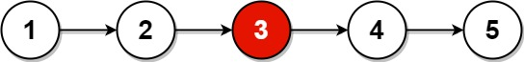

**Input:** head = [1,2,3,4,5]

**Output:** [3,4,5]

**Explanation:** The middle node of the list is node 3.

**Example 2:**



**Input:** head = [1,2,3,4,5,6]

**Output:** [4,5,6]

**Explanation:** Since the list has two middle nodes with values 3 and 4, we return the second one.

**Constraints:**

* The number of nodes in the list is in the range [1, 100].
* 1 <= Node.val <= 100